Mantid
PM report to Project Management Board
24th November 2014
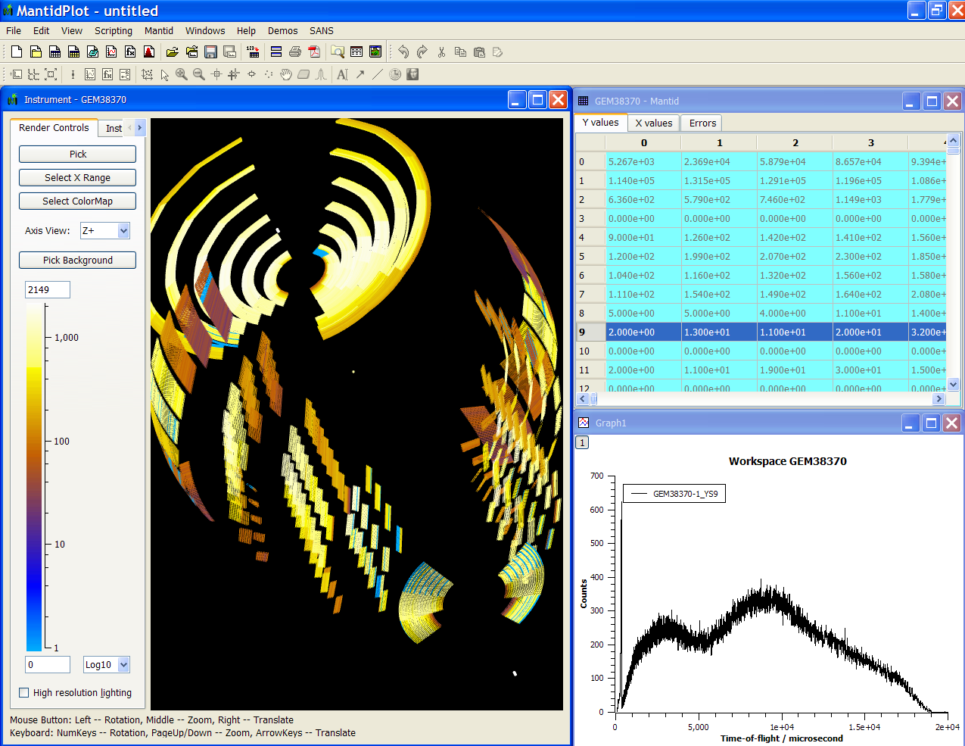
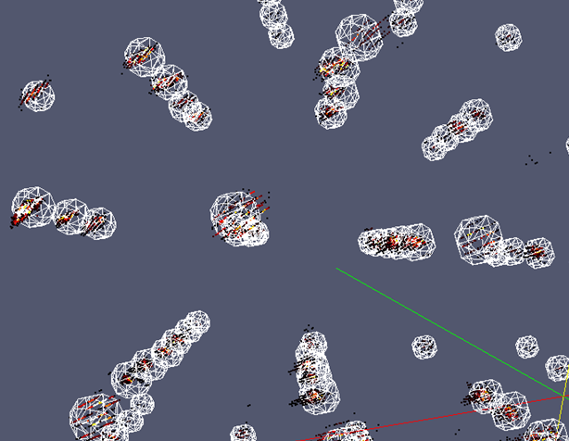
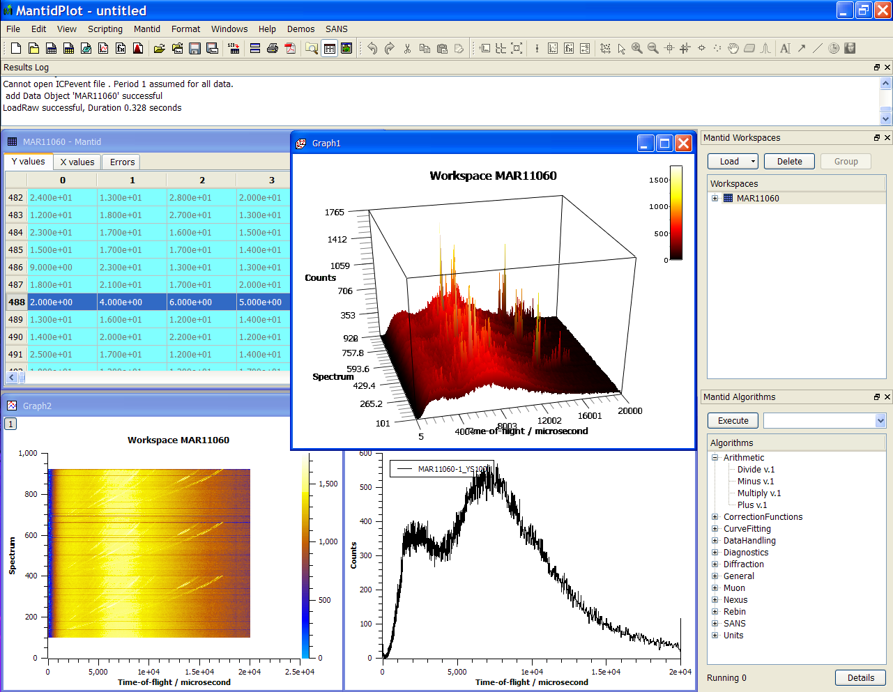
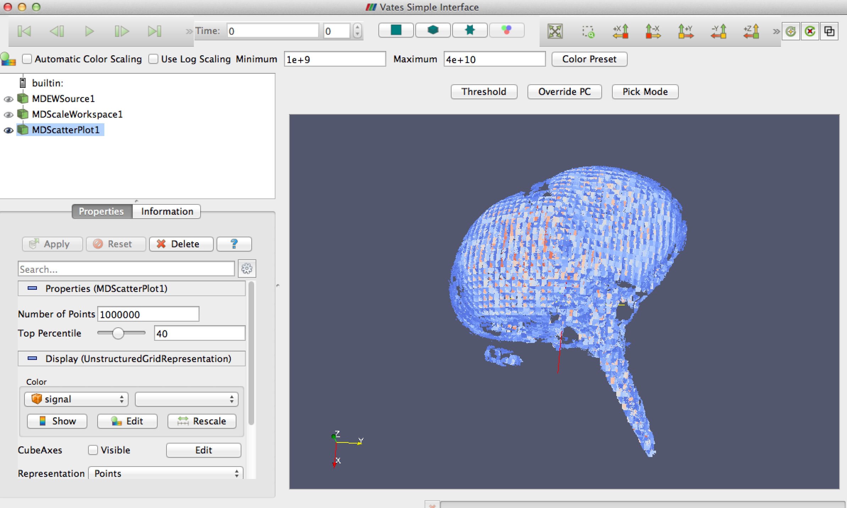
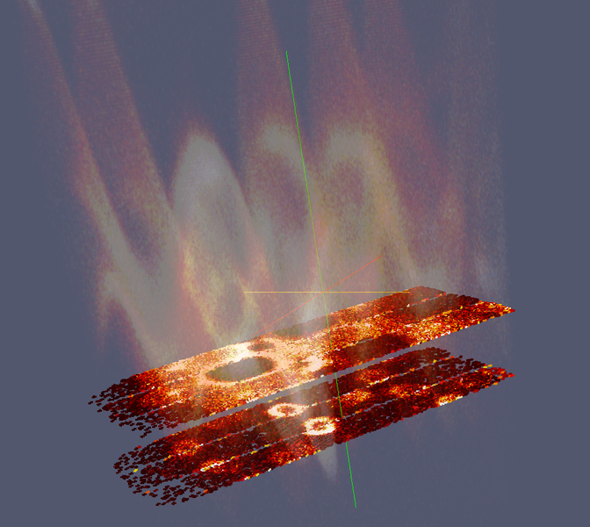
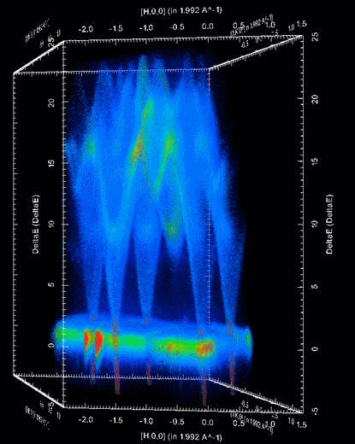

Document Control
This document is under document control. All members of the distribution list will receive updated copies whenever alterations are made. All other copies are uncontrolled.

Contributors
Name | Role | Company
Nicholas Draper | Author | Tessella

Document Approval
Name | Role | Company

Distribution
Name | Role | Company
Project Management Board Members | Recipient | STFC & ORNL
Mantid Project Repository | Filing | STFC & ORNL

Revision History
Author | Issue | Date | Description
Nicholas Draper | V1.R1.M0 | 31-Mar-2014 | 1st version written

References
Document | Ref | Date | Details and Version
Project Specification | [PS] |  | https://github.com/mantidproject/documents/blob/master/Project%20Management/ProjectSpecification.doc?raw=true
Stakeholder Plan | [SP] |  | https://github.com/mantidproject/documents/blob/master/Project%20Management/StakeholderPlan.doc?raw=true
Risk Register | [RR] |  | https://github.com/mantidproject/documents/blob/master/Project%20Management/RiskRegister.xls

Table of Contents
1 Introduction 3
2 Election of Chairman, or extension of current chairperson 4
3 Minutes of the previous meeting 4
4 Project Documentation 4
5 Project Status 4
6 Update on progress of SSC requirements 5
7 Report from the TSC 6
8 Plans for scientific steering committee meeting and developer meeting at ISIS 6
9 Supported Environments 6
10 Instrument definition file – new format? 6
11 Handling of error bars during fitting small values 7
12 Tracking Usage Data 7
13 Interest from Other Facilities 8
14 Future Release Dates 8
15 Appendix A: Metrics 9

Introduction

Purpose of this Document
This report details the current state of the Mantid project and presents the agreed agenda for discussion. The project management board will use the information in this report as a basis for the meeting.

Scope of this Document
The scope of this document is limited to the Mantid project, both for progress up to the meeting of the Project management board, and plans for the future.

Context of this Issue
This is the thirteenth project management report to the Mantid project management board and will provide input to the meeting.

Election of Chairman, or extension of current chairperson
We need to elect a new chairperson, or agree to extend Thomas’ tenure as Chairperson.

Agreement of PMB seats per facility
We agreed to consider the contribution over the last 12 months by each facility to decide how many PMB voting seats each facility should get for the following year. I have included some metrics on Ticket completion and code commits in the appendix 15.3, but the clear message is that both ISIS and the SNS are contributing highly, and I suggest we continue with 3 seats for ISIS and the SNS and 1 for ESS for the following year.

Minutes of the previous meeting
The minutes of the previous meeting are available here:
https://github.com/mantidproject/documents/blob/master/Project-Management/PMB/Minutes/PMCMinutes21stJuly14.docx?raw=true

Project Documentation
The project documentation is available through the links below. The Risk Register has been reviewed and updated. The other documents have not been changed since the last PMB meeting.

Stakeholder Plan:
https://github.com/mantidproject/documents/blob/master/Project%20Management/Stakeholder Map.doc?raw=true
No changes this time

Risk Register:
https://github.com/mantidproject/documents/blob/master/Project%20Management/RiskRegister.xls
No changes this time

Project Status

Development Progress
Since the last PMB meeting in July 2014 we agreed to adjust the planned release dates such that the next release is planned for the 17th of January 2015. As such only release since the last PMB meeting was the patch release:
- Release 3.2.1 22-Aug-2014
Development continues at a good pace: see the project metrics in section 15.2.

Update on progress of SSC requirements

Completed in Release 3.2
id | summary | status | owner
8919 | Better usage examples in documentation | closed | Anders Markvardsen
8909 | Tiled Graph Displays | closed | Roman Tolchenov
8913 | History depth / extracting scripts | closed | Samuel Jackson
8917 | Documentation maintenance | closed | Karl Palmen
8922 | Load performance History | closed | Samuel Jackson
8923 | Plotting improvements | closed | Martyn Gigg
8932 | Mslice interface - Design | closed | Steve Miller
9300 | Correct handling of Fast logs in time slicing | closed | Wenduo Zhou

Planned for Release 3.3
id | summary | status | owner
10502 | Ipython on a server | new | Owen Arnold
8916 | Improve vates visualisation defaults | assigned | Peter Peterson
9105 | New MD normalization framework | inprogress | Andrei Savici
8911 | MultiDataFitting | closed | Roman Tolchenov
8912 | Python Command Line interface improvements | verifying | Federico M Pouzols
8915 | GUI design guidelines | assigned | Martyn Gigg
8918 | Algorithm naming conventions/standards | assigned | Martyn Gigg
8920 | Load performance HDF5 | assigned | Peter Peterson
8924 | Repo. for instrument files | inprogress | Nick Draper
8925 | Specify API for instrument control | assigned | Nick Draper
8927 | Verification of the ISIS quick scripts (with liquids) | closed | Jean Bilheux
8928 | Unify ISIS refl simple UI to work everywhere | assigned | Jean Bilheux
8929 | refl benchmarks | assigned | Jean Bilheux
8930 | Fix rectangular detector issues | assigned | Vickie Lynch
8945 | Measure loading performance for large files and optimize | closed | Nick Draper
9295 | Artur GUI working with Liquids (outside of mantid if necessary) | assigned | Jean Bilheux
9304 | Inelastic planning tools - Porting existing tools | assigned | Peter Peterson
9307 | Improvements to SliceViewer User expreience | assigned | Peter Peterson
9308 | Include different resolution models for quantification | assigned | Jose Borreguero
9718 | Outstanding Documentation Maintenance | assigned | Karl Palmen
10110 | Improvements to VSI User Experience | assigned | Peter Peterson

Report from the TSC
From Stuart Campbell.

Plans for scientific steering committee meeting and developer meeting at ISIS
The dates are set, rooms booked, instrument scientists have been invited from the SNS, and travel requests are underway.

Draft agendas are here http://www.mantidproject.org/Category:January_2015_Visit

We have 1 developer from PSI and 2 from Julich, and probably some from the ILL planning to join us for the developer meeting

Supported Environments
We currently fully support the following environments, With the SNS moving from RHEL to Fedora for data reduction and analysis we should consider updating the list.

- RHEL 6 64bit
- Windows 7 64 bit
- Ubuntu LTS 64 bit
- OS X Mountain Lion
Single build server:
- Windows 8 64 bit
- Fedora 20
Do we have to support RHEL 7 as well? What OS will the ESS use?

Instrument definition file – new format?
Garrett has raised a desire from the SNS to look at a new format for the instrument definitions within Mantid. The current solution has evolved over some time, and is not exactly a perfect design, but currently suffices in most cases. The costs of moving to a new format are likely to be significant, especially if we plan to port over all the existing instrument definitions. I suggest we task the TSC to look propose a new format and report on the costs and benefits of change to the next PMB.

Handling of error bars during fitting small values
One of the strengths of Mantid is that the fitting framework takes the errors of the data into account when fitting models. This however can become a problem with small values, and with 0 in particular.

Mantid currently handles 0 error values by replacing the error value with 1 (the Poisson approximation), There is also the option to ignore 0 error values from the fitted data (Ignore invalid data). However this does not help if the values in not 0, but close to 0, and out of scale to the rest of the data.

Garrett has been discussing this with some people at the SNS.

Tracking Usage Data
There are several situations where the development team, and possibly the PMB would benefit from tacking the usage of Mantid. For example consider the following questions
- What environments are Mantid actually used on, and in what proportion
- Is this algorithm ever used? Can we safely make changes?
- We have two similar Algorithms – can we retire one?
- Is the ??? interface used? Should we continue supporting it?

As such we would like to introduce the capability for Mantid to report back to a central location, information on the following would be recordrd:
- The version of Mantid used and the operating system on startup
- The algorithms used (possibly with parameters)
- The Interfaces used

We would follow the restrictions:
- All data would be recorded against external ip address, no user names would be recorded
- No passwords would be transferred (these are identifiable in MaskedProperties)
- All the data recorded would be publically accessible, and therefore transparent
- If Mantid could not report usage data (due to firewall restrictions etc) it would continue to function normally

As this involves tracking our users usage of our software we would like approval from the PMB before going ahead.

Interest from Other Facilities

ILL
Mark Johnson has received funding for three years from January 2015, to adopt and adapt Mantid within the ILL. The funding roughly covers 3 developers. The current labour laws in France stipulate that temporary staff are limited to a maximum of 18 months, followed by a 6 month break for the position. Mark is looking at other ways to resource the project and has approached Tessella which has provided a proposal.
I have also suggested to Mark that he might want to consider requesting membership of the collaboration and passed on the membership applications from ISIS, SNS and ESS as examples.

CSNS
I have had some contact with Junrong Zhang from the CSNS. He asked a few questions about membership to feed to his facility director, specifically:
1. How much is funding per year from CSNS?
2. How many manpower will be involved?
3. How long will the protocol last?
4. What is the organization?
I have answered all of these as best I can and passed on the membership applications from ISIS, SNS and ESS as examples.

Julich
We recently discovered through the Mantid training courses that there are two developers (Marina
Ganeva and Celine Durniak) at Julich working on Mantid under Jochim Wutke. They are currently working as contributors, but may be interested in membership later. The two developer will be joining us for the Developer workshop.

Future Release Dates
The planned release dates for the future are:
- v3.3 17th January 2015
- v3.4 2nd July 2015
- v3.5 1st October 2015
- v3.6 30th January 2016
This does not include patch releases.

Appendix A: Metrics

Project Metrics
The code metrics are independently generated and displayed here
http://www.openhub.net/p/Mantid/analyses/latest/languages_summary
Total Lines : | 2,530,239 |  | Code Lines : | 1,882,140 |  | Percent Code Lines : | 74.4%
 |  |  | Total Comment Lines : | 357,671 |  | Percent Comment Lines : | 14.1%
 |  |  | Total Blank Lines : | 290,428 |  | Percent Blank Lines : | 11.5%

In a Nutshell, Mantid...
- ...has had 38,229 commits made by 77 contributors
representing 1,882,140 lines of code
- ...is mostly written in C++
with an average number of source code comments
- ...has a well established, mature codebase
maintained by a very large development team
with stable Y-O-Y commits
- ...took an estimated 529 years of effort (COCOMO model)
starting with its first commit in April, 2007
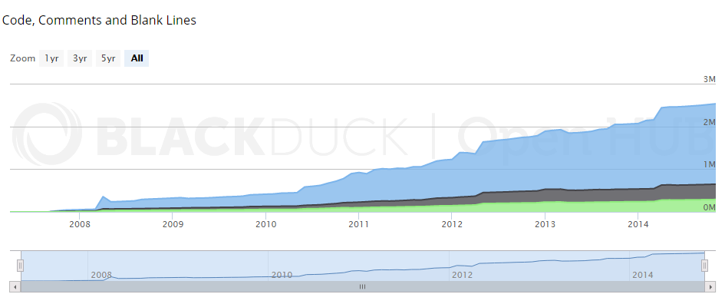

Ticket completion rate
Development on Mantid is performed in three -four month iterations, each of which ends with an official release of the software. Longer pieces of work sometimes have to span a development iteration in which case that piece of work appears as completed only in the iterations when it becomes available to the users.
The patch releases (2.x.x) are very much smaller and are used to solve issues that become apparent after the main release or release urgent improvements that have recently been added.

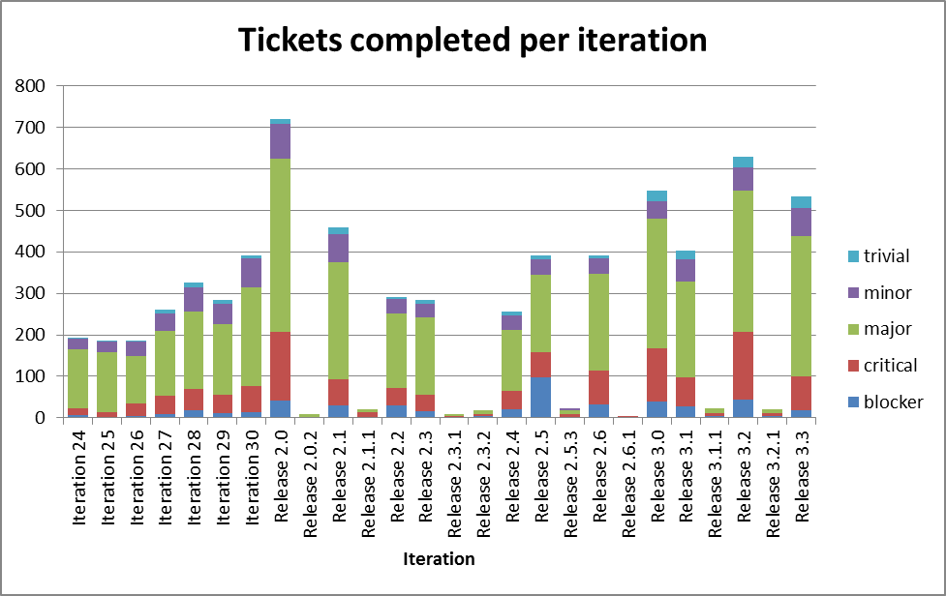
The release 3.3 is still under development..

Ticket and Commit metrics over the last 12 months

